**Generate ajaxget link to pass parameters from web to EVO3**

The function “ajaxGet” allow passing of parameters (example coordinates, radius of a circle) from the web to the EVO3 tools.

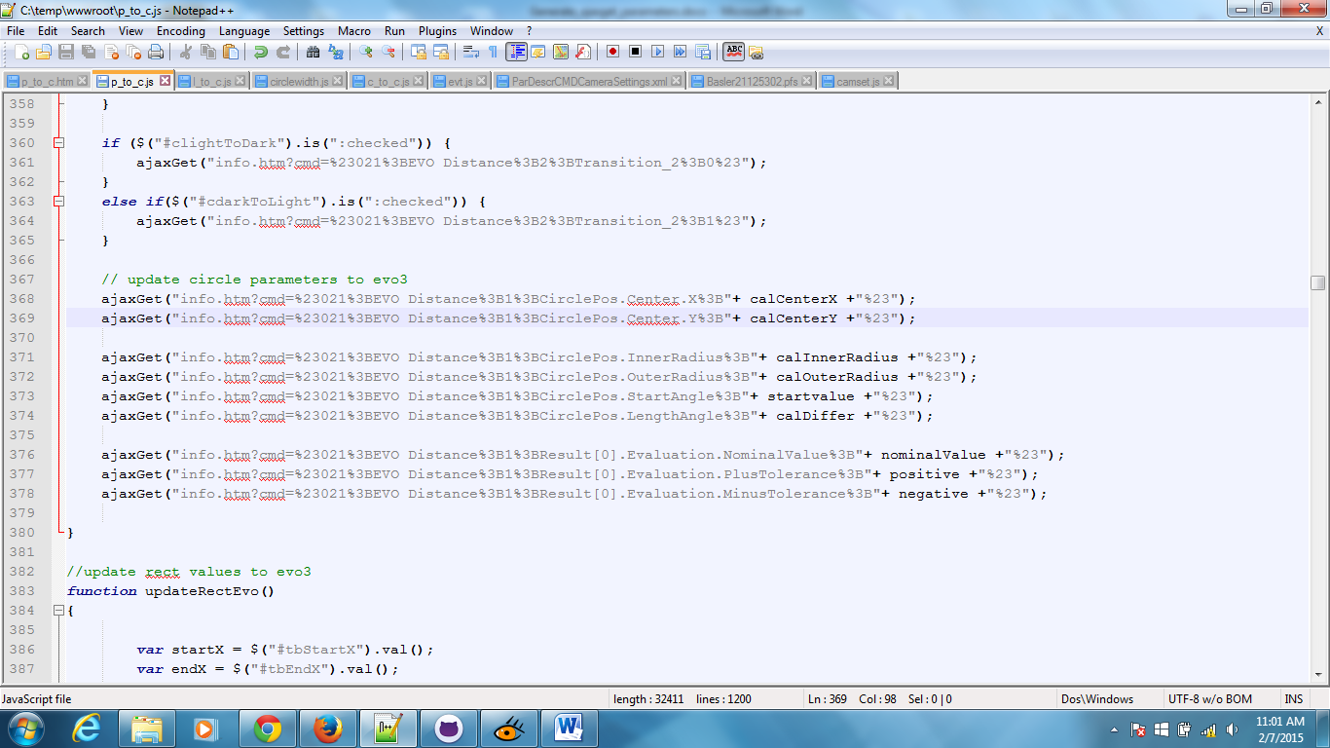

In order to generate the following parameters:

ajaxGet("info.htm?cmd=%23021%3BEVO Distance%3B1%3BCirclePos.Center.X%3B"+ calCenterX +"%23");

This example shows that it is using a “021” command and the full command will be #021;<CmdName>;<ParType>;<ParName>;<Value>#

|  |  |
| --- | --- |
| Hexadecimal conversion | |
| From | To |
| # | %23 |
| ; | %3B |

<CmdName>: Command name in the comment column of the command

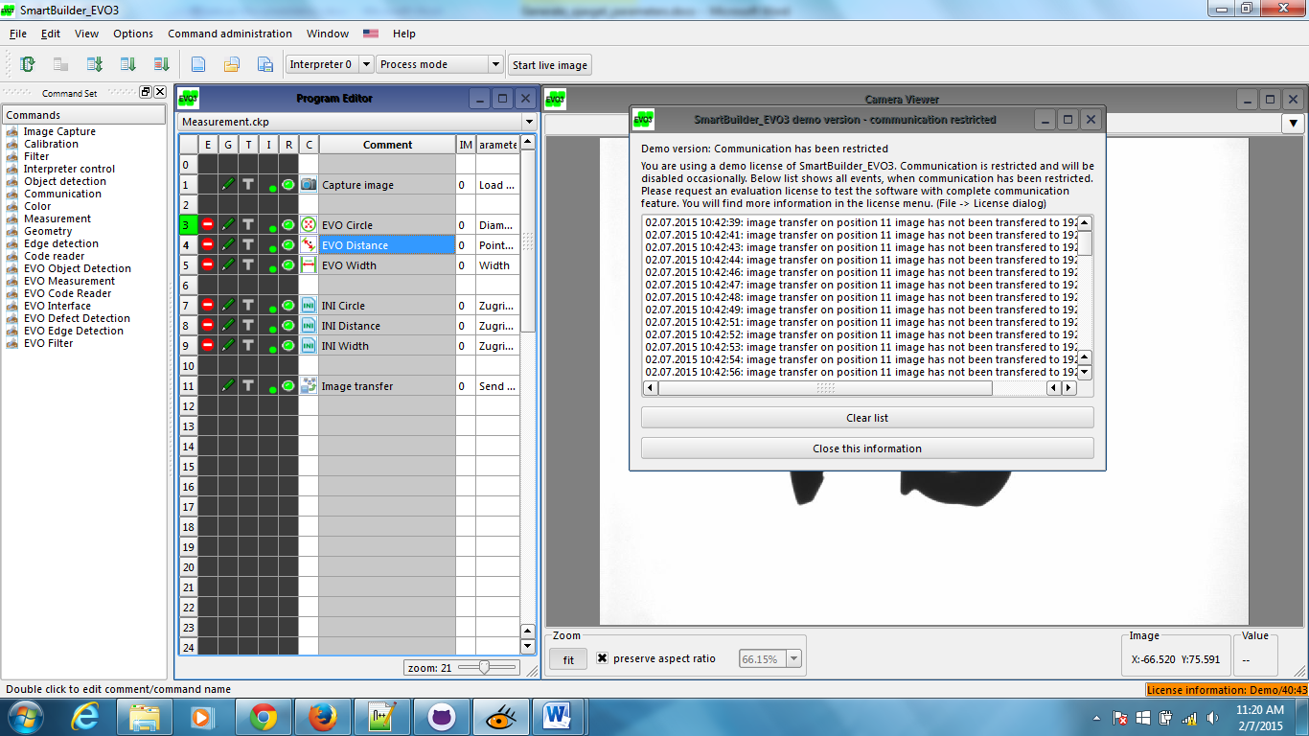

<ParType>: Type of parameters – 0 = String, 1 = Double, 2 = Long

(For “Enum” type, please check the library file of the command plugin to determine the actual parameter type.)

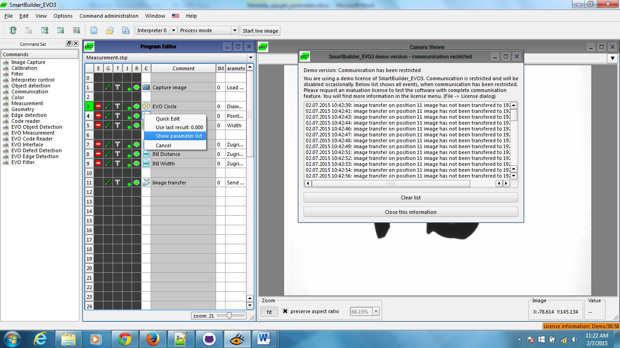

This will determine the parameter type to use.

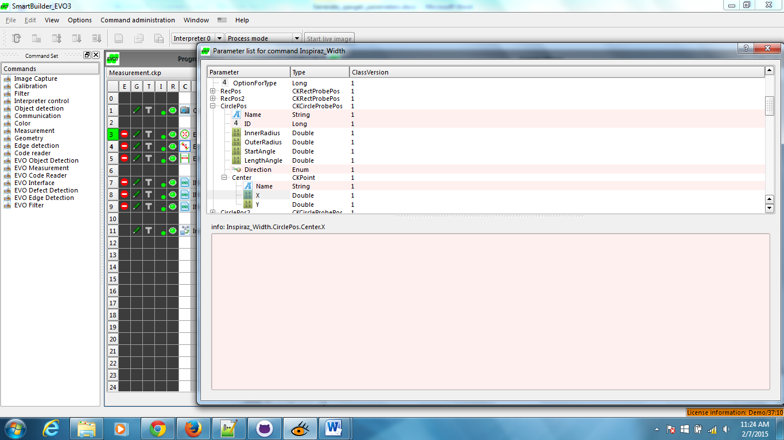

<ParName>: Name of the parameters



<Value>: Value to be set

In this case either set a value or replace it with a variable

